SQL QUERIES

(A) List ac_no of customer having due payment more than 5000000.

SQL-
set search_path to production;
select ac_no from
(select ac_no, cost_of_account-total_advance as due_payment
from (select ac_no, sum(amount) as total_advance from advance group by ac_no) as G natural join
(select ac_no, sum(final_cost) as cost_of_account
from
(select o_id,total_transportation_charge + cost_of_order as final_cost
from
(select o_id, sum(cost_of_item) as cost_of_order
from
(select o_id,product_cost+additional_charge as cost_of_item
from (select o_id,i_id,qty*rate as product_cost
from item) as A natural join item) as B
group by o_id) as C natural join (select o_id, sum(transportation_charge) as total_transportation_charge from transportation
group by o_id) as D) as E natural join order_detail
group by ac_no) as F) as H
where due_payment> 5000000

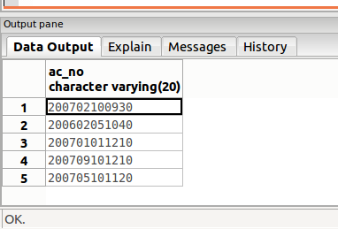

(B) List name, ac_no, o_id of customers with total amount payable> 200000000

SQL-
set search_path to production;
select name, ac_no, o_id, total_amount
from
(select o_id, ac_no,total_amount
from
(select o_id, total_transportation_charge + cost_of_order as total_amount
from
(select o_id, sum(cost_of_item) as cost_of_order
from
(select o_id,(product_cost + additional_charge) as cost_of_item
from
(select qty* rate as product_cost from item) as A natural join item) as B
group by o_id) as C
natural join
(select o_id, sum(transportation_charge) as total_transportation_charge
from transportation
group by o_id) as D) as E natural join order_detail) as F natural join customer_detail
where total_amount> 200000000
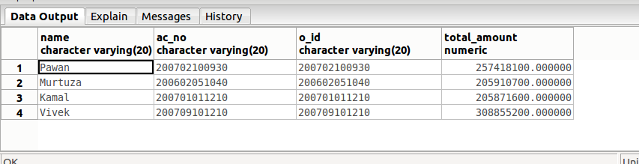
(C) List item names and their count which feature more than 5 times. (Popular items)

SQL-
set search_path to production;
select item_name, count(o_id)
from item_detail natural join item
group by item_name
having count(o_id) > 5
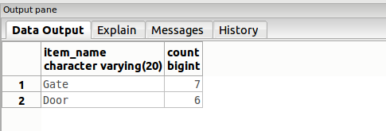

(D) List name, phone no., address, orders of customer who's ac_no='200601011230'.

SQL-
set search_path to production;
select o_id, name, phone_no from customer_detail natural join order_detail
where ac_no = '200601011230'

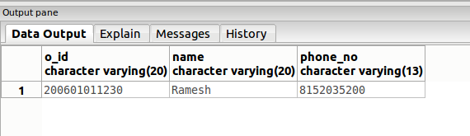
(E) List the payment details of a customer with ac_no='200601011230'.

SQL-
set search_path to production;
select name, amount, date_of_payment, payment_seq_of_day
from customer_detail natural join advance
where ac_no= '200601011230'

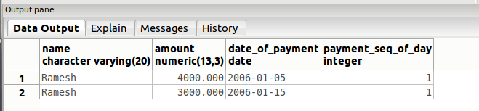
(F) List total of each item of order id= '200601011230'.
SQL-
set search_path to production;
select i_id, item_name, specification, qty, rate,item_cost, trans_charge_of_one_item,additional_charge, item_cost + additional_charge + trans_charge_of_one_item as total
from (select i_id, item_name, specification, qty, rate, qty*rate as item_cost, additional_charge
from item natural join item_detail
where o_id='200601011230') as A natural join (select i_id, sum(transportation_charge) as trans_charge_of_one_item
from delivery join transportation on delivery.o_id= transportation.o_id
group by i_id
order by i_id) as B
